

OPERATING AND MAINTENANCE MANUAL
Synergy STX Water to Water
DWSW Pneumatic
08/11/2026
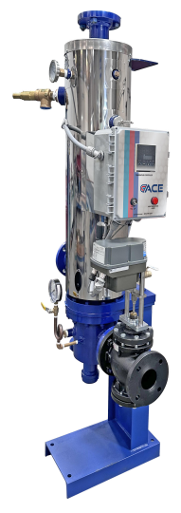
-IMPORTANT-
Always reference the full model number and serial number when calling the factory.
HUBBELL ELECTRIC HEATER COMPANY
45 SEYMOUR STREET
STRATFORD, CT 06615

PHONE: (203) 378-2659
FAX: (203) 378-3593
Hubbellheaters.com

Contents
Operating and Installation Instructions (WW Pneumatic) 3
STX Nameplate 4
STX Model Number 4
Parts of the STX 5
How It Works! 6
Receiving Your STX 7
General Installation Instructions 7
Installation Diagram (Single-Wall) 9
Installation Diagram (Double-Wall) 10
Before Start-up 11
Start-Up Instructions 11
Shut Down Instructions 13
Safety Features 13
Trouble Shooting 14
Maintenance Instruction 15
Removing the Tube Bundle 16
Gasket Installation 16
Tube Bundle and Bonnet Installation 17
Preventive Maintenance 19

Operating and Installation Instructions (WW Pneumatic)

Congratulations on your purchase of a new Hubbell STX. In this book, we have included installation and maintenance instructions that, if followed, will provide you with many years of service from your new unit. Also included are instruction manuals for each of the controls furnished with the heater. Please read them carefully. They should be helpful in both the installation and service of this unit. Keep these instructions with the STX for future reference.

The Hubbel STX is of rugged construction, yet of simple design. The heater uses steam (or water) from a boiler to heat domestic water. The STX temperature control system enables it to control the heated water within + 4°F of the selected temperature during normal operating conditions. This close control is accomplished by placing the temperature control element directly in the constant flow path of the hot domestic water outlet. The integral circulator constantly recirculates a portion of the heated water to the cold-water inlet, making the total volume of the heater a tempering chamber. This also eliminates any overheated water pockets caused by control valve lag when the hot water demand is suddenly reduced.

The STX features total rust-free construction with austenitic stainless and copper for all domestic water contact surfaces, providing a high quality, low maintenance and an extremely cost-effective domestic water heating package.

The tubes are rolled and flared into a stainless-steel tube sheet. All Hubbell STXs can be serviced completely without breaking the domestic water lines or disturbing the heater foundation.

Each STX is constructed and stamped in accordance with Section VIII, Div. 1, of the ASME Code, which is stamped on the STX rating plate.

Experience in the field has proven that the Hubbell STX, if properly applied and maintained, will give many years of efficient, dependable and economical service.

STX Nameplate
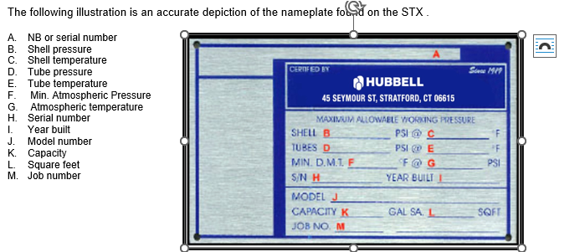

STX Model Number
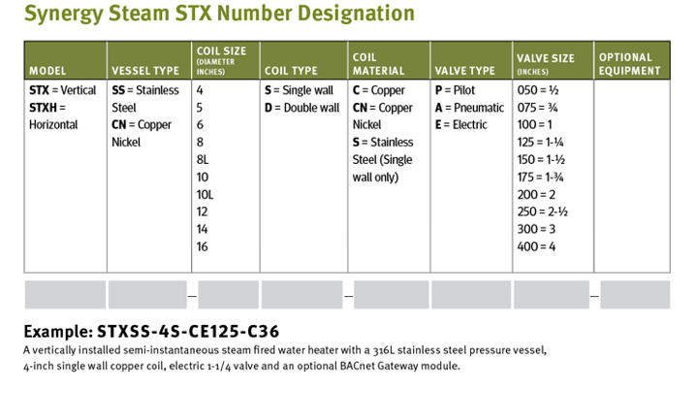

Parts of the STX
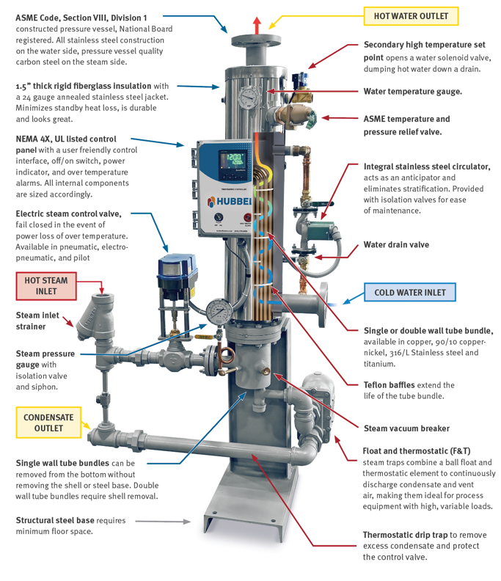

How It Works!

The STX is designed to heat domestic hot water using existing plant steam or hot boiler water and regulates the domestic hot water outlet temperature to a close tolerance of +4°F from the set point. The advantage of this system is it replaces the need for large hot water storage tanks and is much more efficient.

As there is a demand for domestic hot water, the temperature control bulb will sense the drop in water temperature. The temperature bulb sends a signal to the control valve to open and allow steam or hot boiler water into the heat exchanger tube bundle. As the steam or hot boiler water passes through the tubes, the domestic water in the shell is rapidly heated. Above the tube bundle, a minimal water volume storage area is provided to give the controls sufficient time to react to the changes in water temperature.

The circulator constantly rotates the water in the shell, eliminating any hot spots, which could cause false readings at the control valve.

As the steam or boiler water passes through the tubes, it is sub-cooled by the incoming domestic cold water. As the demand for hot water fluctuates, the control valve will respond accordingly, quickly reacting to keep the water temperature within +4°F. In the event the water temperature in the STX continues to climb, the high limit control will trip, cutting the electrical current to the solenoid valve on the control panel, which in turn relieves the air signal to the control valve and causes it to close.

On units equipped with a double safety solenoid valve, the system is designed to dump the overheated water through the solenoid dump valve when the high limit is tripped.

Receiving Your STX

Check Equipment Received. Inspect the unit for any shipping damage. Make sure you have received all loose parts, as listed on the “Bill of Lading”. Larger strainers, usually 2 ½ײ and above, are shipped loose. Note any damages or shortages on the bill of lading prior to signing it. If the STX is received damaged or missing parts, it is your responsibility to notify the shipping company and file a freight claim. Hubbell Heaters cannot send replacement parts for freight damaged or missing equipment as warranty items. Permission to return goods must be received from the factory prior to shipping. Goods returned without a Returned Goods Authorization number will not be accepted. Purchased parts are subject to replacement only under the manufacturer’s warranty. The warranty does not include the cost of labor, removal, or installation of the warranted part.

General Installation Instructions
NOTE: All electrical and piping installation should only be accomplished by qualified personnel following all applicable local, and state codes required for their installation.

Code Requirements: It is very important that your installation comply with all federal, state and local codes as well as meet good industry practices as shown in publications issued by ASME, UL, ASHRAE, ABMA, etc.

Placement: The STX can be mounted two ways; either vertically on its base or horizontally, using its mounting brackets for wall, ceiling or rack mounting. The STX should be installed on a solid foundation, preferably a concrete pad or with heavy duty bolting if mounted on a wall or ceiling. Provide adequate clearance for normal inspection and maintenance purposes and allow tube pull clearance from the base of the unit. A minimum clearance of 24” is recommended from all accessories for ease of maintenance. Make sure the STX is level, from side to side and front to back. Use metal shims if necessary.

Piping: Control valve hot water supply line shall be flushed prior to installation or with the shut-off valve closed to isolate the STX from the system. This is imperative to avoid any damage to the valve seat during startup procedures AND TO AVOID WARRANTY ISSUES. All piping to and from the STX must be provided with adequate supports and expansion compensation so that pipe stresses are not transmitted to the STX. The relief valve and the double-safety solenoid valve, if supplied, should be piped to a safe drain.

Stud Nuts: During shipment, the bonnet and shell flange nuts may loosen and should be re-tightened before start-up. Tighten these nuts to the torques specified later in this manual. After the unit has been in operation for a few days and periodically thereafter, check and retighten. Note: Bolting is independent on the bonnet and shell-side flanges through the use of a threaded tube sheet flange(s). Therefore, stud bolt nuts must be re-tightened on both sides. See Figure 1.1 for single-wall bolting arrangement and Figure 1.2 for double-wall bolting arrangement.

Torque's: The following are recommended bolt torque requirements

MP Size | Bolt Size* | Gasket Thickness** | Compressed Thickness | Min Torque | Max Torque***
 | (Y) |  | (X) | (T) | (T)
4" | 1/2" | 1/4" | 0.018" | 45 ft.lb | 60 ft.lb
5" | 1/2" | 1/4" | 0.018" | 45 ft.lb | 60 ft.lb
6" | 1/2" | 3/8" | 0.025" | 45 ft.lb | 60 ft.lb
8" | 1/2" | 3/8" | 0.025" | 45 ft.lb | 60 ft.lb
10" | 5/8" | 3/8" | 0.025" | 90 ft.lb | 120 ft.lb
12" | 5/8" | 3/8" | 0.025" | 90 ft.lb | 120 ft.lb
16" | 5/8" | 1/2" | 0.035" | 90 ft.lb | 120 ft.lb
Notes:
* Spray each stud bolt and nut generously with penetrating oil before re-torque.
** Gasket thickness before compression. All partition gaskets are ⅛ײ in width before compression. All gaskets expand twice their width after compression.
*** These are recommended torque values. Stud bolts must not be stressed above 60% of their yield strength.

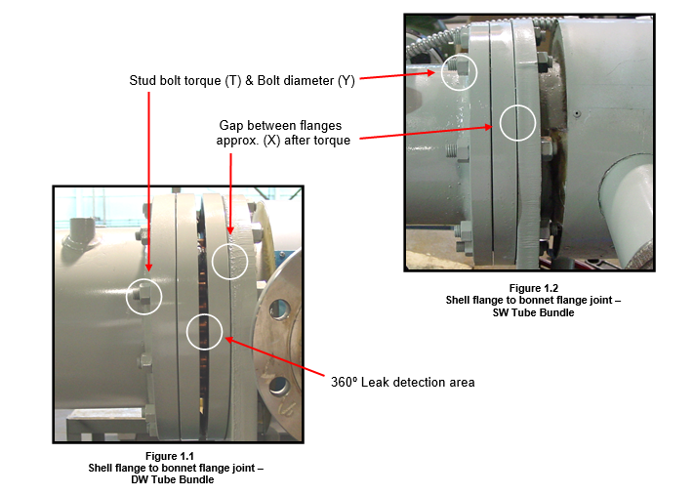

Water Connections: See Typical piping diagram (Page 9 and 10).

Relief Valve: The relief valve discharge must be piped to a floor drain to eliminate the potential of scalding burns. The drain line must be the same size as the relief valve outlet and have a downward slope to ensure proper drainage. The drain line termination should be visible to see discharge. Check the relief valve nameplate. The unit's operating pressure cannot exceed that listed on the relief valve.

Electrical: The STX is wired for 120volts 60hz 1phase 3 amps, unless otherwise noted on the heater nameplate. Verify the electrical supply using a voltmeter. The voltage tie-in leads are indicated on the wiring diagram. For your safety, turn off electrical power supply at the service entrance panel before making any electrical connections. This unit contains sensitive control components and should be protected by a suitable commercial grade surge protection device and electrically grounded. The STX must be installed in accordance with the National Electric Code and all state and local codes.

Water Treatment: Proper water treatment plays an important role in protecting the life of your investment. Hubbell Heaters recommends consulting a water treatment specialist prior to start-up for recommendations on water treatment. The STX uses boiler steam or hot water as its heating medium. On hot water systems, boiler makeup water continuously introduces contaminants; scale forming solids, corrosive minerals and oxygen, which can cause corrosion or scale formation inside the STX tube bundle. Whenever appreciable amounts of raw makeup water are continuously added to your system, we recommend that the problem be brought to the attention of a qualified water consultant. Proper treatment will ensure longer product life and reduced maintenance.

Control Valve Air Supply Pressure: The pneumatic controller used on the STX requires a reliable, compressed air supply. The air supply to the control valve shall be 30 PSI. Optimum supply pressure to the temperature controller is at least 35 PSI.

Double Safety Solenoid Valve (optional): If so equipped, the solenoid valve discharge must be piped to a floor drain. The drain line must be the same size as the solenoid valve outlet and have a downward slope to ensure proper drainage. The drain line termination should be visible to see discharge.

Installation Diagram (Single-Wall)

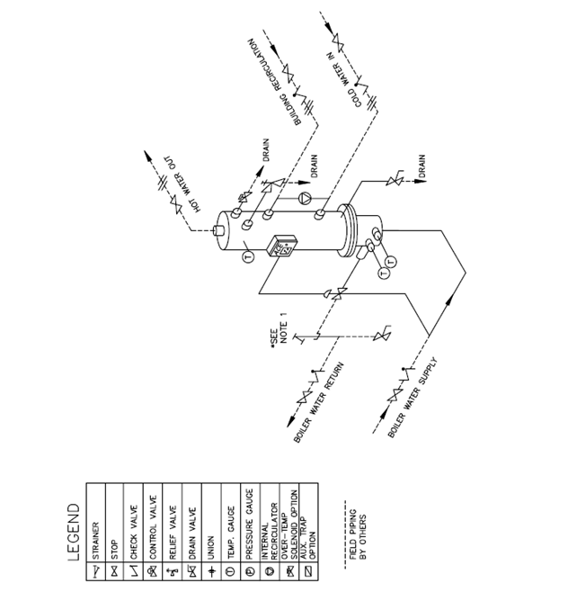

Installation Diagram (Double-Wall)

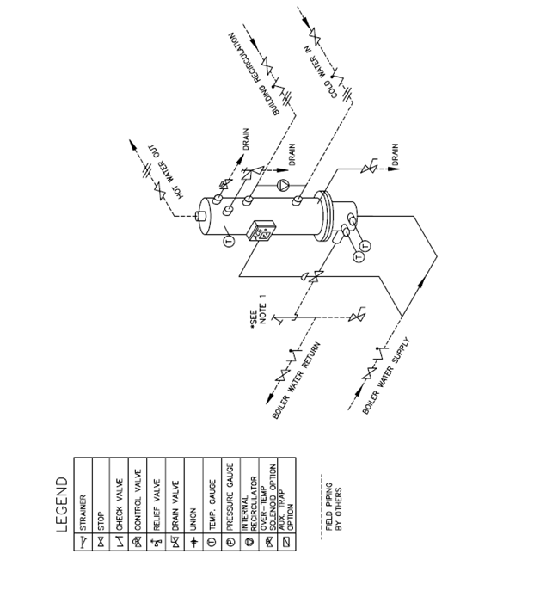

Before Start-up
- Verify the STX is installed in accordance with the appropriate installation diagram located on (Page 9 and 10).
- It is recommended that a strainer be installed upstream of the control valve to entrap any damaging debris in the system and extend the life of the coil and control valve. It is also recommended that isolation valves and temperature gauges be installed upstream and downstream of the control valve. This is ideal for periodic maintenance purposes.
- Verify 120volts 60hz 1phase voltage supply to the control panel. No additional field wiring is required. Caution: The toggle switch on the control panel must be in the "off" position prior to connection to the power source. Failure to do so may damage the safety solenoid if so equipped.
- Verify an air supply pressure of at least 35 PSI to the to the air filter regulator upstream of the Accritem.

Start-Up Instructions
- It is assumed that installation is complete and that all connections have been made, including: electrical, water boiler, domestic water, instrument air, vents, drains and safety valve discharge lines. Prior to start-up inspect the strainer for any dirt, scale, welding particles or debris that may have accumulated during construction. Make sure the General Installation procedure has been followed (See Page 7).

- Make sure the power switch is in the “off” position.

- Set the high limit control (figure 2.0) 12° to 15°F higher than the Accritem (figure 2.2) setting (Domestic hot water outlet temperature). For example, if the system is heating domestic water from 40 to 140°F, the high limit should be set at ~152°F. The high limit aquastat will automatically reset when the temperature drops the set differential number of degrees. The adjustable differential (figure 2.1) should be set so that the system does not start up again until the water temperature drops at least 5 degrees below the desired hot water outlet temperature (typically 135°F on a 140°F system). Continuing the example, with the high limit set at 152°F, the differential should be set at least 17, thus ensuring that the system does not start heating until the water temperature drops 17 degrees down to 135°F. Remove the cover to access the adjustment wheel. Refer to the included manufacturer's data sheet for adjustment information.

Figure 2.0 Figure 2.1 Figure 2.2
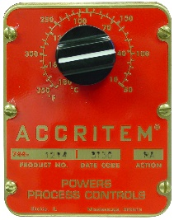
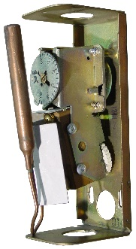
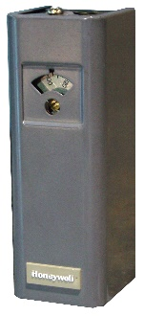

- Close the shut-off valve on the bonnet side (heating medium side). Slowly introduce domestic water to the unit by opening the shut-off valves at the inlet and outlet of the shell. This will allow water to circulate in the shell. Open the relief valve when filling to purge the trapped air from the unit.

- Plant boiler water is used as the heating medium and is controlled by a pneumatic control valve, which in turn receives its signal from the temperature controller (Accritem). Connect the air supply to the filter/regulator (minimum 35 PSI supply to the air pressure regulator). The instrument air supply gauge on the pressure regulator should be regulated to 30 PSI to the Accritem. If the control valve is equipped with a valve positioner these pressures will still apply. The outlet pressure gauge on the Accritem should read 30 PSI when fully opened, and 0 PSI when fully closed. Under normal operating conditions the outlet gauge reading will fall within this range.

- Set the temperature knob on the Accritem (figure 2.2) to its lowest temperature setting.

- Turn on the system by turning the control panel switch to the “ON” position (The manual boiler water supply valve should be closed at this time). The green light should come on. At the same time, it will energize the solenoid on the control panel allowing air to the control valve actuator, which in turn will open the control valve. Make sure the circulator pump is running. (Please refer to the pump instruction manual for details.)

- Turn on several hot water fixtures to establish a steady 50% load if possible, with at least a flow of 8 to 10 GPM for the initial startup. Make sure these stay on and there is not an additional load applied elsewhere during initial startup.

- Manually open the main boiler water shut-off valve upstream of the control valve and SLOWLY allow boiler water to pass through the control valve. Continue until the shut-off valve is 100% open.

- The STX will now function automatically, reacting according to demand fluctuations and will stabilize once limits are met.

- Slowly increase the system temperature output by adjusting the temperature knob on the Accritem (figure 2.2). Watch the temperature gauge on the front of the unit and wait for the temperature to stabilize prior to turning it up again. Repeat this procedure slowly until the desired outlet temperature set point has been achieved. Please note that the temperature knob on the Accritem may not be accurate to the actual water temperature (see gauge on shell). Once you have achieved your set point, it is recommended to loosen the set screw on the knob and reposition as necessary to indicate the actual (gauge) temperature on the Accritem face plate.

- Once stabilized, turn off the hot water fixtures one at a time and watch the temperature gauge on the unit. There should only be slight temperature fluctuations. With no hot water fixtures on, the temperature gauge should remain stable. Watch the temperature for 5 minutes to verify the valve has closed. If the temperature slowly creeps up, the valve is leaking hot water and may have debris on the seat or the valve requires "zeroing". "Zeroing" the valve requires adjusting the stem length until the valve closes tightly. See Page 14 under Trouble Shooting.

- With the system warm, check the operation of the high limit safety control (figure 2.0). Do this by rotating the temperature dial to its lowest setting and setting the Accritem control 20° above the high limit set point. Check that the temperature of the system matches the temperature set point of the high limit when it engages and shuts the control valve (the red high temp light will engage on the control panel as well). Caution: Very hot water may splash as it is discharged; take the necessary precautions to avoid contact. Return the temperature dial to the desired set point.

- Observe the entire system over a period of variable loads to determine if any calibration is necessary on the Accritem temperature controller. The sensitivity of this controller is adjusted by turning the restriction screw. (See inserts on the Accritem enclosed).

- After start-up, inspect the strainer for any dirt, scale, welding particles or debris that may have accumulated and remove as necessary; any debris can damage the valve seat or obstruct it from full shut-off, resulting in possible over-temp conditions and/or scalding.

- Check the flange bolt section for leaks. Tighten only enough to stop leakage. Never tighten more than necessary. Excessive tightening will shorten the life of the gasket and stretch the studs. See Page 7 for proper torque values.

Shut Down Instructions

- De-energize all electrical power to the STX.
- Close the main upstream hot water shut-off valve to the STX.
- Close domestic water inlet and outlet shut-off valves.
- Allow the unit to cool down. (Approximately 24 hours).

Safety Features
- The pneumatic hot water control valve is designed to fail safe (closed) in the event of a power failure.
- The single safety solenoid (standard) closes the air line from the Accritem to the actuator upon an over-temp or power failure. The three-way valve also vents any air left in the actuator, thus ensuring full shut-off of the control valve.
- The relief valve is designed to relieve the pressure in the STX in the event the pressure gets too high.
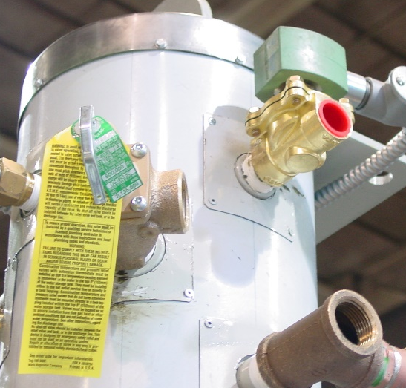
- The double safety solenoid (Optional feature, figure 3) is designed to dump the hot domestic water from the shell in the event that the water temperature exceeds the set point on the high limit control. This should be piped to a safe drain per local and state codes.

Figure 3

Trouble Shooting

- Water temperature too high:
- Check the setting of the Accritem and its sensitivity screw (and positioner if provided), and verify a steady 30 PSI air supply pressure to the Accritem. The outlet pressure gauge on the Accritem should read 30 PSI when fully opened, and 0 PSI when fully closed. If this is not the case the sensitivity screw needs adjustment or the air passage is clogged. Under normal operating conditions the outlet gauge reading will fall within this range.
- Confirm boiler water supply pressure to the control valve conforms to that specified in the List of Materials (See List of Materials enclosed).
- Confirm that the domestic water inlet and outlet valves are 100% open.
- Make sure the integral circulator pump is operational.
- Check for proper condensate drainage, cleaning out any dirt and debris. Condensate should flow by gravity to a condensate receiver.
- Check to see if the Packing gland around the valve stem is too tight or the valve stem is bent (See Technical Data sheets enclosed).
- Check for proper spring tension on air operated valves (See Technical Data sheets enclosed).
- Check for dirt under the valve seat and/or damage to the seat (See Technical Data sheets enclosed).
- The temperature bulb's sensing element may be dysfunctional (See Technical Data sheets enclosed).
- Banging or pinging:
Check and ensure that no air is present in the domestic piping or the hot water boiler lines. Relieve any air pockets as necessary.
- Erratic temperature control:
- Check the setting of the Accritem and its sensitivity screw (and positioner if provided) and verify a steady 30 PSI air supply pressure to the Accritem. The outlet pressure gauge on the Accritem should read 30 PSI when fully opened, and 0 PSI when fully closed. If this is not the case the sensitivity screw needs adjustment or the air passage is clogged. Under normal operating conditions the outlet gauge reading will fall within this range.
- Make sure the integral circulator pump is operational.
- Check for proper flow direction of the circulator pump. The pump should be flowing downwards to the cold domestic inlet nozzle.
- Confirm boiler water supply pressure to the valve is steady and agrees with that specified in the List of Materials. (See List of Materials enclosed).
- Check the control temperature bulb for exterior scale or buildup and clean if necessary.
- Check for and clean out any debris in the upstream strainer, valve body, and valve seat.
- Sticking valve stem. This can be caused by a bent valve stem or a valve stem not properly lubricated. A sticking valve stem can also be caused by the packing gland assembly being too tight. Loosen the packing gland assembly and lubricate.
- Poor recovery:
- Check the setting of the Accritem and its sensitivity screw (and positioner if provided), and verify a steady 30 PSI air supply pressure to the Accritem. The outlet pressure gauge on the Accritem should read 30 PSI when fully opened, and 0 PSI when fully closed. If this is not the case the sensitivity screw needs adjustment or the air passage is clogged. Under normal operating conditions the outlet gauge reading will fall within this range.
- Confirm boiler water supply pressure to the control valve meets that specified in the List of Materials. Check for a clogged strainer, a partially closed supply valve or other obstructions.
- Make sure the STX is not trying to supply more hot water than it was designed for (See performance listed in List of Materials enclosed).
- Shut unit down, remove bonnet and coil. Inspect for scale and fouling, which restricts proper heat transfer. Clean with an approved chemical treatment as necessary.
- Control Valve not closing:
- Check the setting of the Accritem and its sensitivity screw (and positioner if provided) and verify a steady 30 PSI air supply pressure to the Accritem. The outlet pressure gauge on the Accritem should read 30 PSI when fully opened, and 0 PSI when fully closed. To achieve full shut-off, it is imperative that the outlet pressure gauge reads 0 PSI. If this is not the case the sensitivity screw needs adjustment.
- The packing gland assembly is too tight, locking the valve stem (See Technical literature enclosed).
- The temperature stem nut assembly is raised too high (See Technical literature enclosed).
- Check for proper operation of the control valve solenoid. The solenoid should be energized and open when the system is in normal operating conditions. When the system is off or an over-temp condition occurs, the solenoid should be de-energized and venting air out of its third port.
- Check for and clean out any debris in the upstream strainer, valve body, and valve seat. The valve seat may be worn or damaged and unable to seal properly (See Technical literature enclosed).
- Zeroing the Powers Actuator: The actuator spring tension has been factory set. If the valve is leaking hot water, the actuator spring range requires adjustment. Follow the steps below and refer to the manufacturer's Technical instructions enclosed for more explicit direction.
To decrease spring tension on normally closed assembly.
- Apply air pressure to the actuator to place the valve at "mid-stroke".
- Hold the actuator stem in place and loosen the valve stem locknuts. Do not turn the actuator stem at any time during this process as this may damage the diaphragm.
- While holding the actuator stem in place, turn the valve stem into the actuator stem (towards the actuator) to the desired position (1/4 to 1/2 turn each time) using the locknuts. Retighten the locknuts when finished.
To increase spring tension on normally closed assembly.
- Apply air pressure to the actuator to place the valve at "mid-stroke".
- Hold the actuator stem in place and loosen the valve stem locknuts. Do not turn the actuator stem at any time during this process as this may damage the diaphragm.
- While holding the actuator stem in place, turn the valve stem out of the actuator stem (away from the actuator) to the desired position (1/4 to 1/2 turn each time) using the locknuts. Retighten the locknuts when finished.

For other trouble shooting issues, please reference the specific control sheets included in this manual.

Maintenance Instruction

KEEP TUBES CLEAN: In order to maintain high efficiency, the STX tubes should be cleaned periodically. The frequency of cleaning the tubes depends on the characteristics of the water and the type of installation. Contact your local water treatment company for evaluation and recommendations.
GASKETS: Tighten gaskets during start up and periodically thereafter. Leaky gaskets can cause corrosion of the stud bolts. It is good practice to use a new gasket each time the tube bundle or bonnet is removed.
STUDS: Keep studs protected from corrosion with paint or oil. Keep stud bolts tight to prevent leaky gaskets. Stud bolts will not corrode if they are kept dry and protected. Use caution in removing and reinstalling the bonnet. The STX must be shut down and drained before attempting removal. Before removing the nuts, apply penetrating oil and allow it to set for a few minutes. Forcing the nut off could cause breakage. Use a torch to heat the nut and it will come off easier. If a torch is not available, take a cold chisel and place it across the flat of the nut and strike several sharp blows with a heavy hammer. This should loosen the nut. If necessary, it is better to split the nut open and replace it than to break the stud off.
CONTROLS: Under normal conditions, controls furnished with the STX require very little service. It is important, however, that the controls be protected from moisture. All controls should be checked frequently to make sure that they are working properly.
RELIEF VALVE: The STX is equipped with a lever type relief valve of “ASME” rated capacity. To maintain the valve in good working condition, it should be manually opened once a month. The relief valve outlet should be piped directly to an open drain and the drain checked frequently for discharge. If the relief valve is leaking or does not operate freely it should be replaced.
HIGH LIMIT AQUASTAT: The STX is equipped with a high limit temperature safety aquastat designed to shut down the unit in the event the water temperature exceeds the high limit set point. The high limit should be set 12ºF to 15°F above the desired domestic hot water outlet temperature set point. For example, if the system is heating domestic water from 40ºF to 140°F, the high limit should be set at ~152°F. The high limit aquastat will automatically reset when the temperature drops the set differential number of degrees. The adjustable differential should be set so that the system does not start up again until the water temperature drops at least 5 degrees below the desired hot water outlet temperature (typically 135°F on a 140°F system). Continuing the example, with the high limit set at 152°F, the differential should be set at least 17, thus ensuring that the system does not start heating until the water temperature drops 17ºF down to 135°F. Refer to the included manufacturer's data sheet for adjustment information. Turn the high limit safety control up and down to verify proper operation.

Removing the Tube Bundle
Caution: It is recommended that you wear gloves and eye protection.

- Shut down the unit as described in the shut down instructions.
- After the STX has cooled, isolate the STX by closing off the manual valves at the domestic water inlet and outlet locations. Drain the water remaining in the shell to a safe sewer drain.
- Disconnect the hot water inlet line and condensate outlet line from the tube bundle bonnet.
- Remove the nuts from the bonnet side first in order to remove the bonnet. Care must be taken when lowering the bonnet.
- The tube bundle can now be removed by removing the nuts holding it to the shell.
- Caution: The tube bundle is very heavy. Care should be taken when removing it from the shell. Approximate tube bundle, bonnet, and shell weights without base are as listed.

STX Component Weights

Single-wall units Double-wall units
MP Size | Coil Weight | Bonnet Weight | Shell Weight
4" | 30 lbs. | 30 lbs. | 60 lbs.
5" | 54 lbs. | 40 lbs. | 73 lbs.
6" | 77 lbs. | 45 lbs. | 85 lbs.
8" | 110 lbs. | 60 lbs. | 115 lbs.
8L" | 132 lbs. | 60 lbs. | 125 lbs.
10" | 200 lbs. | 95 lbs. | 180 lbs.
10L" | 230 lbs. | 95 lbs. | 200 lbs.
12" | 253 lbs. | 130 lbs. | 250 lbs.
12L” | 300 lbs | 130 lbs. | 300 lbs.

MP Size | Coil Weight | Bonnet Weight | Shell Weight
5" | 125 lbs. | 40 lbs. | 95 lbs.
6" | 170 lbs. | 45 lbs. | 105 lbs.
8" | 260 lbs. | 60 lbs. | 135 lbs.
10" | 430 lbs. | 95 lbs. | 210 lbs.
12" | 550 lbs. | 130 lbs. | 310 lbs.

Gasket Installation
Caution: It is recommended that you wear proper eye protection.
- Thoroughly clean the gasket surface of foreign matter and scratches. Dirt and scale provide leakage paths.
- Lubricate the bolts and the underside of the nuts. A heavy graphite and oil mixture will do. Threads should be well formed and free running. Lubricating the threads doubles the clamping force.
- Gasket should be properly positioned before attempting to retighten bolts. The placement of the gasket is important and must be done on a clean surface area. It covers a very thin area, which widens as the bolts are tightened. Place the gasket on the flange toward the outside of the gasket sealing area so that a width of the flange is approximately equal to half the width of gasket is on the outside (as shown in VIEW "A", D equals width of gasket). Peel back adhesive strip protective paper and firmly press down gasket as you go around flange. The adhesive strip will hold the gasket in position. Flanges, especially blind flanges, bend appreciably when bolts are torqued and might come together without adequately compressing the gasket if it were placed further toward the inside of the flange face.

- Complete the seal by crossing the ends near a bolt hole. Cross one end over the other about 1" and cut (as shown in VIEW "B").
- Assemble the flanged joints and torque the bolts as follows.
- Run up all the nuts, finger tight.
- Develop the required bolt stress in a minimum of about three equal steps, following a tightening sequence (as shown in VIEW "C"). The gasket material is highly compressible, but has little resilience; so gradual tightening is necessary to form a gasket of uniform thickness. Use a torque wrench to get recommended torque rating on Page 7.

Tube Bundle and Bonnet Installation
Caution: It is recommended that you wear proper eye protection.
- Flange and tube sheet preparation: Thoroughly clean the gasket surface of foreign matter and scratches. Dirt and scale provide leakage paths.
- Apply gaskets: Install gasket material on stationary flange with adhesive side down. See Step #3 from Gasket Installation above on Page 16.
  - Overlap material at top of flange.
  - Overlapped ends should protrude out of flange, with one end on each side of top bolt.
  - Make sure gasket does not extend into bore.
Gasket Material
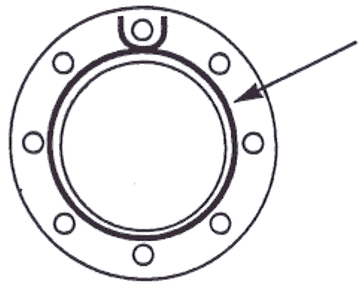

- Install heat exchanger bundle: Bundle should be lifted or jacked with care as to not damage the tubes or tube sheet gasket surface. Lift the bundle to the proper height prior to tightening nuts down. Do not use the nuts to lift the bundle into the shell. Bundle should be left supported until installation is complete.
- Apply gasket material on channel bonnet: Overlap gasket material around bolt hole as above. Apply gasket on divider sections as well. Overlap the divider gasket strips over the main gasket.

- Bolting bonnet: Use jack or overhead support to lift bonnet into position, align with the bolts that are in place, level and slide the bonnet against tube sheet. Install nuts on bolts in place and tighten finger tight. The bonnet should be left supported until installation is complete.
- Torque: Unless otherwise specified, when using Gore-Tex or spiral wound gaskets, use the following table to find recommended bolt tightening torque.

MP Size | Bolt Size | Minimum Torque | Maximum Torque
4" | 1/2" | 45 ft.lb | 60 ft.lb
5" | 1/2" | 45 ft.lb | 60 ft.lb
6" | 1/2" | 45 ft.lb | 60 ft.lb
8" | 1/2" | 45 ft.lb | 60 ft.lb
10" | 5/8" | 90 ft.lb | 120 ft.lb
12" | 5/8" | 90 ft.lb | 120 ft.lb
16" | 5/8" | 90 ft.lb | 120 ft.lb

- Torque bolts: Set torque wrench to half of recommended torque rating. Tighten bolts according to alternating crossover pattern. Do not over tighten any one bolt initially as this could crimp the gasket. The sequence is to lightly tighten the first bolt then move directly across the circle for the second bolt. Continue as illustrated below. Tighten each bolt in increments repeating the cycle until half torque ratings are reached. Reset torque wrench to full torque rating and repeat tightening sequence in increments until full torque ratings are reached. Remember, for the gaskets to work properly, the flange faces must be kept parallel and the bolts tightened uniformly.
- Completion: When bolt-tightening sequence is complete, remove the support from the tube sheet and the channel bonnet.

Preventive Maintenance
Every 3 months:
- Visually check for leaks at any joints, including the valve body, piping, and controls.
- Visually check for corrosion on the control valve, Accritem, bulb, and strainer.
- Check for full valve shut-off. Refer to Trouble Shooting section on Page 14.
- Check for full valve travel. Less than full valve travel may indicate a leak in the diaphragm or bulb, or a plugged air line.
- Test the Accritem control knob for freedom of movement. Lubricate if necessary.
- Remove the Accritem from the STX and check the temperature control bulb for any corrosion or erosion. Remove/clean any scale from bulb surface.
- Strainers should be inspected and cleaned. Damaged screens should be replaced with same mesh.
- Check and tighten flange nuts as needed.

Annual Maintenance:
- The relief valve must be tripped to ensure proper operation as a safety device.
- Pull the tube bundle and clean the inside and outside of the tube bundle of scale. The frequency of tube cleaning will be determined after inspection. (Heavy scale will indicate that more frequent cleaning is necessary). A light sludge or scale coating on the tube greatly reduces its effectiveness. A marked increase in pressure drop and/or reduction in performance usually indicate cleaning is necessary. The tube bundle should be cleaned with a tube brush and/or an acceptable cleaning solution.
- Check ALL operating components for proper functionality. Check all electrical connections.

Replacement Parts
Hubbell Heaters maintains a complete equipment list for each STX, filed by serial number. In order for us to give prompt service and to ensure that correct parts are supplied, please be sure and supply the model and serial number.

Replacement parts may be ordered directly from manufacturer.

Material Data Safety Sheets
Some Hubbell products contain materials that have been recognized as posing health risks. Material Safety Data Sheets for these materials are available from your local Manufacturer's rep. When requesting this information, be sure to have the model number and serial number available.

If you do not know who your local Manufacturer's Rep is, you can find out by logging into the HubbellHeaters.com website, and clicking on the Representative tab found in the table of contents.

Hubbell Heaters LLC
45 Seymour Street
Stratford, CT 06615
203-378-2422
www.HubbellHeaters.com

